Task #2
Database

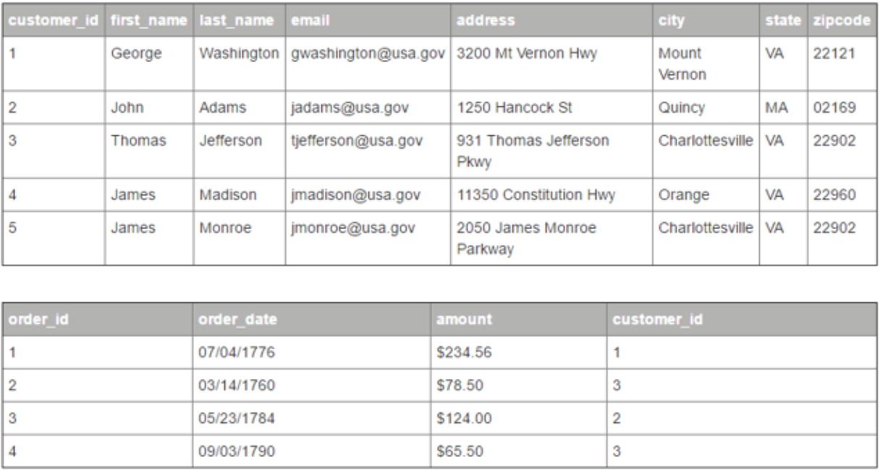
1. Write SQL query to list how many customers are from the ‘VA’ state
2. Write SQL query list all customers, who made an order and details of the order;

Create tables “Customers”, “Orders” and fill them with data

CREATE TABLE Customers(customer_id INT AUTO_INCREMENT, first_name VARCHAR(20) NOT NULL, last_name VARCHAR(20) NOT NULL, email VARCHAR(30) NOT NULL UNIQUE, address VARCHAR(40) NOT NULL, city VARCHAR(30) NOT NULL, state VARCHAR(5) NOT NULL, zipcode INT NOT NULL, PRIMARY KEY(customer_id));

INSERT into Customers values(1, 'George', 'Washington', 'gwashington@usa.com', '3200 Wernan Wey', 'Wernan', 'VA', 22121);
INSERT into Customers values(2, 'Jone', 'Carter', 'jcarter@usa.com', '1212 Hanconc st', 'Quincy', 'VA', 33121);
INSERT into Customers values(3, 'Thomas', 'Jeferson', 'tjeferson@usa.com', '213 Warner Brasers', 'Brasers', 'BR', 32324);
INSERT into Customers values(4, 'James', 'Bond', 'jbond007@usa.com', '007 James st', 'Bond', 'VA', 00700);
INSERT into Customers values(5, 'Jecky', 'Chan', 'jchan@usa.com', '4952 Kievskaya st', 'Vinnitsya', 'AD', 21000);

CREATE TABLE Orders(order_id INT AUTO_INCREMENT, order_date DATE, amaunt FLOAT, customer_id INT REFERENCES Customers(customer_id) ON DELETE SET NULL, PRIMARY KEY(order_id));

INSERT into Orders values(1, '07/04/1776', 234.56, 1);
INSERT into Orders values(2, '03/12/1770', 130.61, 3);
INSERT into Orders values(3, '05/01/1772', 274.04, 2);
INSERT into Orders values(4, '10/10/1775', 734.36, 3);

Make first SQL query

SELECT COUNT(*) FROM Customers WHERE state="VA";

Make second SQL query

SELECT C.first_name, C.last_name, C.email, C.address, C.city, C.state, C.zipcode, O.order_date, O.amaunt FROM Customers AS C, Orders AS O WHERE C.customer_id = O.customer_id;

Make second SQL query using INNER JOIN

SELECT C.first_name, C.last_name, C.email, C.address, C.city, C.state, C.zipcode, O.order_date, O.amaunt FROM Customers AS C JOIN Orders AS O WHERE C.customer_id = O.customer_id ORDER BY C.first_name;

